Given a sorted array arr[] of n elements, write a function to search a given element x in arr[].  
A simple approach is to do a [**linear search**](https://www.geeksforgeeks.org/linear-search/)**.** The time complexity of the above algorithm is O(n). Another approach to perform the same task is using Binary Search.   
**Binary Search:** Search a sorted array by repeatedly dividing the search interval in half. Begin with an interval covering the whole array. If the value of the search key is less than the item in the middle of the interval, narrow the interval to the lower half. Otherwise, narrow it to the upper half. Repeatedly check until the value is found or the interval is empty.

Example:

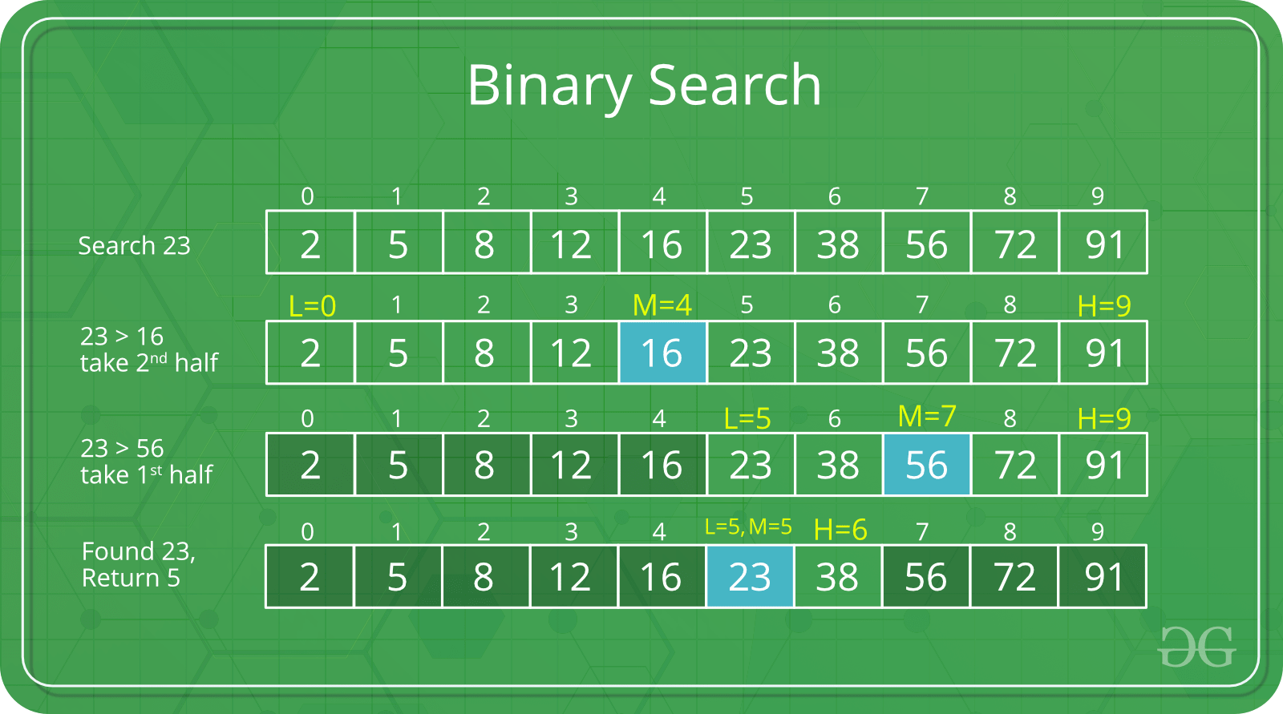

The idea of binary search is to use the information that the array is sorted and reduce the time complexity to O(Log n).

1. Compare x with the middle element.
2. If x matches with the middle element, we return the mid index.
3. Else If x is greater than the mid element, then x can only lie in the right half subarray after the mid element. So we recur for the right half.
4. Else (x is smaller) recur for the left half.

**Recursive**implementation of Binary Search by using C programming language:

**// C program to implement recursive Binary Search**

**#include <stdio.h>**

**// A recursive binary search function. It returns**

**// location of x in given array arr[l..r] is present,**

**// otherwise -1**

**int binarySearch(int arr[], int l, int r, int x)**

**{**

**if (r >= l) {**

**int mid = l + (r - l) / 2;**

**// If the element is present at the middle**

**// itself**

**if (arr[mid] == x)**

**return mid;**

**// If element is smaller than mid, then**

**// it can only be present in left subarray**

**if (arr[mid] > x)**

**return binarySearch(arr, l, mid - 1, x);**

**// Else the element can only be present**

**// in right subarray**

**return binarySearch(arr, mid + 1, r, x);**

**}**

**// We reach here when element is not**

**// present in array**

**return -1;**

**}**

**int main(void)**

**{**

**int arr[] = { 2, 3, 4, 10, 40 };**

**int n = sizeof(arr) / sizeof(arr[0]);**

**int x = 10;**

**int result = binarySearch(arr, 0, n - 1, x);**

**(result == -1) ? printf("Element is not present in array")**

**: printf("Element is present at index %d",**

**result);**

**return 0;**

**}**

Output: Element is present at index 3